This is the title of your contribution. Bold, 14pt
Jane Doe¹, Hong Gildong¹, Jean Dupont¹, Max Mustermann²
- Affiliation of 1st author, city, country
- another affiliation, city, country

keywords: please enter ~3 keywords here (for example: landslides, ground water, mining, IP, landfill, …)
Summary, Bold 12pt
The book of extended abstracts of 2025 will have a DOI! This is a template for your abstract submission to the “Seventh International Workshop on Geoelectrical Monitoring”, which will be held in Vienna from February 17th to February 20th, 2025. Please use the formatting used within this document:
- Calibri, 12 pt for text and 14 pt for the header).
- In total, the extended abstract should be 2-4 pages including figures.
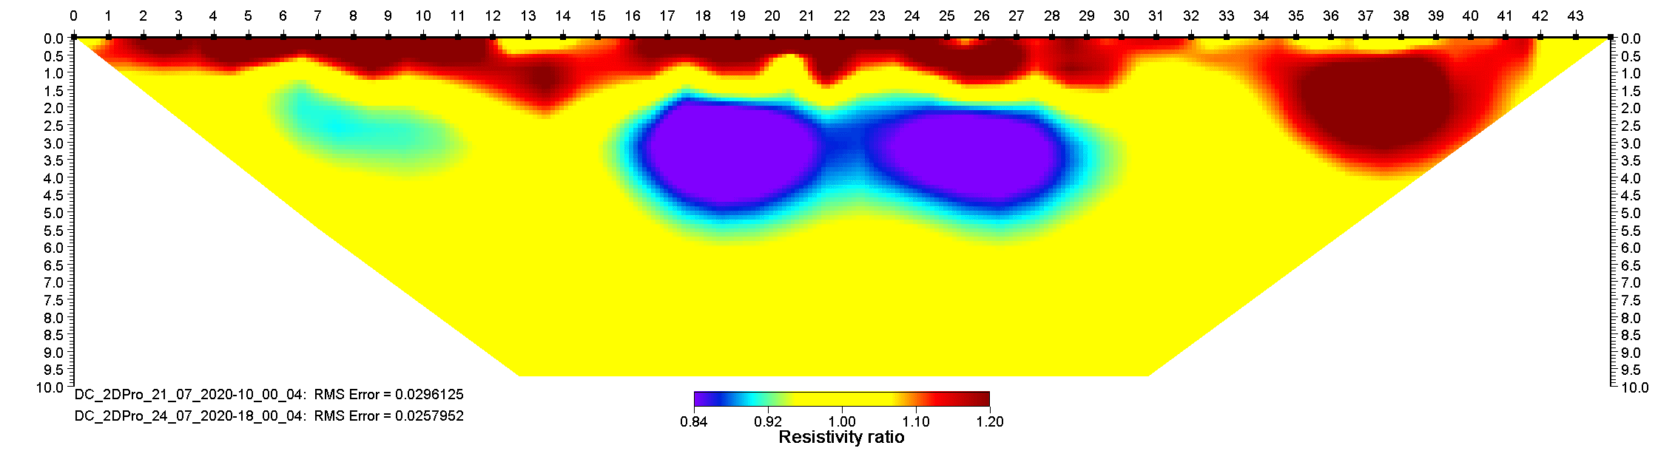
Figure 1 This is an example of the resistivity ratio of 2 geoelectric inversion results.

Introduction
Divide your text into paragraphs as needed.

Other chapters
Example text

Conclusions

Acknowledgements (Optional)

References
Krautblatter, M., Verleysdonk, S., Flores Orozco, A., Kemna, A. (2010): Temperature-calibrated imaging of seasonal changes in permafrost rock walls by quantitative electrical resistivity tomography (Zugspitze, German/Austrian Alps). Journal of Geophysical Research. 115. https://doi.org/10.1029/2008JF001209.

